UNIVERSITY OF MINES AND TECHNOLOGY, TARKWA



FACULTY OF ENGINEERING
DEPARTMENT OF ELECTRICAL AND ELECTRONIC ENGINEERING

A THESIS REPORT ENTITLED

INTELLIGENT MACHINE LEARNING BASED POWER TRANSFORMER FAULT DIAGNOSIS FRAMEWORK USING DISSOLVE GAS ANALYSIS, MATLAB SIMULINK AND PYTHON

BY
JACOB ADDO TAGOE

SUBMITTED IN PARTIAL FULFILMENT OF THE REQUIREMENTS FOR
THE AWARD OF THE DEGREE OF MASTER OF PHILOSOHPY IN ELECTRICAL AND ELECTRONIC ENGINEERING

THESIS SUPERVISOR
……………………………………..
PROF JOHN ANNAN TARKWA, GHANA

SEPTEMBER 2026

DECLARATION

ABSTRACT

DEDICATION

ACKNOWLEDGEMENTS

TABLE OF CONTENTS

LIST OF FIGURES

LIST OF TABLES

LIST OF SYMBOLS

INTERNATIONAL SYSTEM OF UNITS (SI UNITS)

LIST OF ACRONYMS

CHAPTER 1
GENERAL INTRODUCTION

1.1 Background to the Research
Reliable electricity supply underpins the economic and social development of any nation, and power transformers sit at the physical centre of that reliability, stepping voltage up and down at every stage between generation and the end user (Tenbohlen et al., 2023). A single major transformer failure can trigger unplanned outages that ripple through industrial, commercial and residential consumers alike, and the financial exposure created by such failures, through equipment replacement, lost revenue and, in severe cases, fire or explosion damage, is a documented and recurring concern within the utility sector (Tenbohlen et al., 2023).
Ghana's own power sector offers a current illustration of this reality. In April 2026, a GRIDCo transformer fault and associated network faults left large parts of the Volta, Oti and Tema regions without power for an extended period (Graphic Online, 2026), while a national audit of outages between January and March 2024 similarly linked service interruptions on the Electricity Company of Ghana's network to distribution transformer performance (GhanaWeb, 2024). Incidents of this kind underscore that transformer health monitoring is not a peripheral engineering concern but a live operational challenge with direct consequences for the reliability that Sustainable Development Goal (SDG) 7, Affordable and Clean Energy, commits nations to deliver (United Nations, 2015), and for the resilient infrastructure envisioned under SDG 9, Industry, Innovation and Infrastructure.
Dissolved Gas Analysis (DGA) has, for several decades, been the most widely adopted condition-monitoring technique for oil-immersed power transformers (Dladla and Thango, 2025). The technique interprets the concentrations of hydrogen, methane, ethane, ethylene, acetylene, carbon monoxide and carbon dioxide dissolved in the insulating oil to infer the type and severity of an incipient fault long before it develops into a catastrophic failure. Conventional interpretation methods built on this principle, notably the Rogers Ratio Method, the IEC 60599 Three-Ratio Method and the Duval Triangle Method (Duval, 2002), remain in routine use across utilities worldwide. However, these methods rely on fixed, expert-defined thresholds and geometric zone boundaries derived from historical fault populations that do not adapt as new data becomes available (Khan, 2025).
Over the past decade, the growing availability of historical DGA records and advances in computing have opened a data-driven alternative. Machine learning (ML) techniques, including Support Vector Machines, Random Forests, Gradient Boosting methods and Artificial Neural Networks, have been shown capable of learning the relationship between gas concentrations and confirmed fault outcomes directly from data, rather than from fixed rules (Jiao et al., 2024; Velasquez, 2024). This shift mirrors a broader trend across the electric power and energy sector, where artificial intelligence and ML are increasingly embedded into asset management, predictive maintenance and condition-monitoring workflows to reduce operating costs and extend equipment life (Rajora et al., 2024). Similar reasoning underlies recent work applying deep learning to short-term load forecasting in support of SDGs 7, 9 and 13, which demonstrates how data-driven methods in the power sector are increasingly framed as direct contributions to international sustainable development commitments rather than as isolated technical exercises (Miah et al., 2025).
Despite this progress, the deployment of ML-based DGA diagnosis has remained largely confined to offline research settings. The majority of published studies train and evaluate classifiers purely as standalone models, disconnected from any physical representation of transformer behaviour and from the diagnostic workflow an engineer would use in practice (Khan, 2025; Dladla and Thango, 2025). This thesis is motivated by the observation that closing this gap, by integrating a physical and conventional modelling layer with a trained ML classifier inside a single, queryable diagnostic framework, would represent a meaningful step from algorithmic research toward deployable diagnostic tooling, in direct support of the reliability and resilience goals set out under SDG 7 and SDG 9.

1.2 Problem Definition
Although conventional DGA interpretation methods are well established, their reliance on fixed thresholds and geometric boundaries creates two persistent diagnostic problems. First, different conventional methods frequently disagree with one another when applied to the same oil sample, since each was derived from a different historical fault population and applies different ratio boundaries (Khan, 2025). Second, and more critically, all three major methods perform poorly for gas concentrations that fall near their decision boundaries, where a small change in a single gas ratio can shift the diagnosis from one fault class to another (Dladla and Thango, 2025). Figure 1.1 illustrates this structurally: the Duval Triangle method, one of the most widely used conventional techniques, assigns a fault class based on which geometric zone a sample's percentage CH4, C2H4 and C2H2 values fall into (Duval, 2002). A sample whose gas ratios place it close to the D1/D2, or T2/T3 boundary shown in the figure receives a categorical diagnosis with no indication of how close the underlying values were to an entirely different fault class.
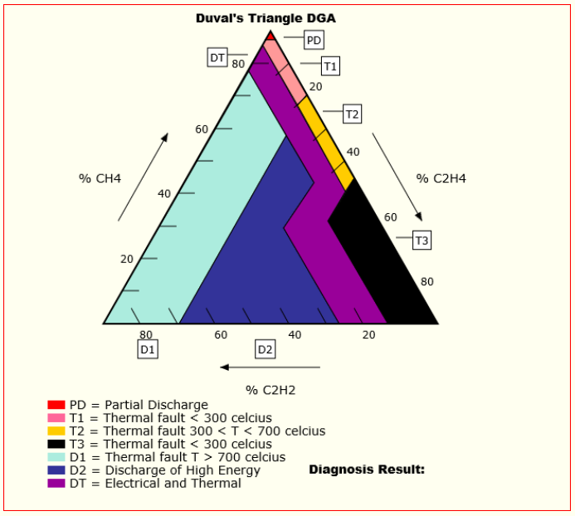
Fig. 1.1 Simplified Schematic of the Duval Triangle Fault-Classification Zones
The consequences of misdiagnosis are not trivial. Analysis of 1,159 major power transformer failures collected by the CIGRE Working Group A2.62 across 66 utilities in 27 countries found that only 61.7% of failures produced no external effect, while 14.0% resulted in fire and a further 14.3% in explosion or burst without fire (Tenbohlen et al., 2023), as summarised in Figure 1.2. Winding-related failures were found to be the largest single contributor to major failures, and bushing failures were most frequently associated with the most severe outcomes (Tenbohlen et al., 2023). Because DGA is often the only warning available before such failures manifest physically, a diagnosis that is ambiguous, delayed or inconsistent between methods directly increases the risk that a developing fault is missed or misclassified until it escalates.
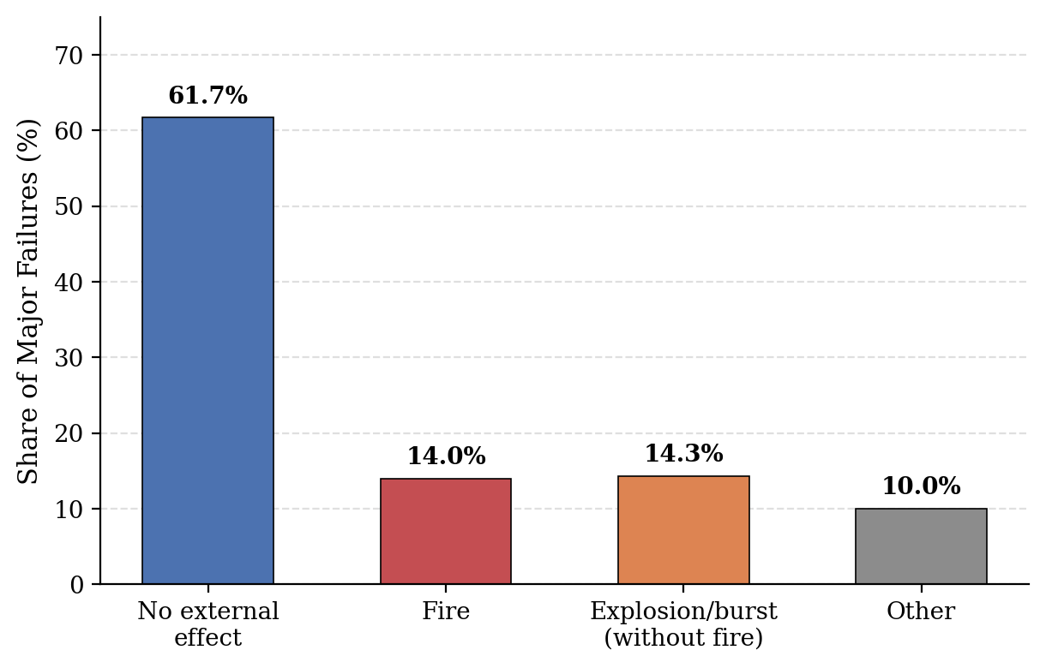
Fig. 1.2 External Effects of Major Power Transformer Failures Worldwide
Machine learning approaches have been proposed as a remedy, and several studies report classification accuracies exceeding 90% on benchmark DGA datasets (Jiao et al., 2024). However, this apparent solution introduces a second, less discussed problem: an ML classifier trained and validated purely offline provides no mechanism by which a practising engineer can compare its output against the conventional diagnosis they are trained to trust, verify its behaviour against a physical understanding of transformer operation, or query it as part of a routine inspection workflow (Rajora et al., 2024).
This disconnect is the central problem this thesis addresses: the absence of an integrated framework in which a physically grounded, conventional DGA interpretation and a data-driven machine learning diagnosis can be generated side by side, compared directly, and made available through a single accessible interface, for a power sector, in Ghana and elsewhere, where transformer reliability already carries direct and recurring economic and social cost.

1.3 Project Objectives
The main objective of this research is to design, implement and evaluate an intelligent power transformer fault diagnosis framework that integrates a MATLAB/Simulink conventional-diagnosis layer with a Python-based machine learning classification engine through a FastAPI service interface. The specific objectives are to:
- develop a MATLAB/Simulink model reproducing the Rogers Ratio, IEC 60599 and Duval Triangle conventional diagnostic methods;
- train and compare five machine learning classifiers (SVM, Random Forest, XGBoost, ANN and Gradient Boosting) on DGA data across six fault classes, and identify the key gases driving the best model's decisions;
- implement a FastAPI service linking the conventional and machine learning layers into a single queryable interface;
- develop a diagnostic dashboard displaying both diagnoses side by side; and
- quantify and statistically test the disagreement between the conventional and machine-learning-based diagnoses.

1.4 Research Questions and Hypothesis
The research questions are stated as follows:
- How do machine learning classifiers compare with conventional DGA interpretation methods in fault classification accuracy?
- Where and why do conventional and machine-learning-based diagnoses disagree?
- Can a conventional modelling layer and a machine learning classifier be combined into one low-latency diagnostic service without loss of fidelity?
The research hypothesis is stated as:
An integrated framework combining a machine learning classifier with a conventional DGA interpretation layer will achieve higher and more consistent fault diagnosis accuracy than either approach used alone, with disagreement between the two concentrating near conventional-method decision boundaries.

Scope of the Research
This research is focused on the development of an integrated machine learning and MATLAB/Simulink-based diagnostic framework for oil-immersed power transformers using the seven standard dissolved gases and six defined fault classes.

Research Methods Used
The research methods used are as follows:
- review of relevant literature;
- machine learning model development and training;
- MATLAB/Simulink modelling; and
- software and systems integration and testing.

Facilities Used for the Research
The facilities used for the research are as follows:
- personal laptop computer;
- MATLAB/Simulink software; and
- Python programming environment with machine learning libraries (scikit-learn, XGBoost) and the FastAPI framework.

Significance of the Research
The significance of this research is summarised as follows:
- the proposed framework can reduce the ambiguity of transformer fault diagnosis for utility engineers by presenting conventional and machine-learning-based diagnoses together rather than in isolation;
- it provides a template for integrating physics-based and data-driven diagnostic methods that can be extended to other power system assets; and
- findings on classifier performance and disagreement patterns contribute empirical evidence to the ongoing academic discussion on the role of machine learning in transformer condition monitoring.

1.9 Limitations of the Research
This research is limited to the six fault classes and seven dissolved gases specified in IEEE C57.104 and IEC 60599 and does not extend to online or continuous DGA monitoring hardware. Model training and evaluation rely on the IEC TC10 and IEEE DataPort datasets rather than newly collected utility data, and conclusions on framework response time are based on a personal-computer deployment rather than a production server environment.

1.10 Definition of Terms and Key Concepts
Dissolved Gas Analysis: A condition-monitoring technique that interprets gases dissolved in transformer insulating oil to detect incipient faults.
Partial Discharge: A localised electrical discharge that only partially bridges the insulation between conductors.
Duval Triangle Method: A graphical DGA interpretation method that classifies faults by plotting the relative percentages of methane, ethylene and acetylene.
Rogers Ratio Method: A conventional DGA interpretation method that classifies faults using coded ranges of three dissolved-gas ratios.
Machine Learning: A branch of artificial intelligence in which algorithms learn patterns directly from data rather than from fixed rules.
Feature Importance: A measure of how strongly each input variable influences a machine learning model’s prediction.
FastAPI: A Python web framework used to expose machine learning models and other services through callable application programming interfaces.
Fault Class: A defined category of transformer incipient fault, such as partial discharge, thermal fault or electrical fault.
Diagnostic Dashboard: A software interface that visually presents diagnostic outputs from one or more analysis methods to a user.
Total Dissolved Combustible Gas: The sum of the concentrations of the principal combustible gases used to assess the overall severity of a transformer's condition.

1.11 Organisation of the Thesis
This thesis is organised into five chapters. Chapter 1 introduces the research problem, background, problem statement and objectives of the research. The chapter further presents the research questions and hypothesis, the scope of the research, the research methods and facilities used, the significance and limitations of the research, and definitions of key terms and concepts. Chapter 2 presents a review of the relevant literature on transformer fault mechanisms, conventional DGA interpretation methods and machine-learning-based approaches to DGA fault diagnosis and situates the study within the identified research gap. Chapter 3 describes the methodology and system design in detail, including the MATLAB/Simulink model, the machine learning pipeline and the FastAPI integration architecture. Chapter 4 presents and discusses the results of the classifier comparison, the conventional-versus-machine-learning disagreement analysis and the framework's performance evaluation. Chapter 5 presents the conclusions drawn from the study and recommendations for future work.

CHAPTER 2
LITERATURE REVIEW

CHAPTER 3
METHOD USED

CHAPTER 4
RESULTS AND DISCUSSIONS

CHAPTER 5
CONCLUSIONS AND RECOMMENDATIONS

REFERENCES
Dladla, V.M.N. and Thango, B.A. (2025), “Fault Classification in Power Transformers via Dissolved Gas Analysis and Machine Learning Algorithms: A Systematic Literature Review”, Applied Sciences, Vol. 15, No. 5, p. 2395.
Duval, M. (2002), “A Review of Faults Detectable by Gas-in-Oil Analysis in Transformers”, IEEE Electrical Insulation Magazine, Vol. 18, No. 3, pp. 8–17.
Graphic Online (2026), “GRIDCo Technical Challenge, Transformer Faults Plunge Volta, Oti, Tema Regions into Darkness”, Graphic Online, 23 April.
GhanaWeb (2024), “ECG's Attribution of Power Outages to Transformer Faults Inaccurate – PURC”, GhanaWeb, 16 April.
Jiao, F., Ma, Z., Chen, Q., Zhang, F. and Zhao, D. (2024), “A Causal Reasoning Approach for Power Transformer Failure Diagnosis”, Frontiers in Energy Research, Vol. 12, Article 1340421.
Khan, M.A.M. (2025), “AI and Machine Learning in Transformer Fault Diagnosis: A Systematic Review”, SSRN Electronic Journal.
Miah, M.S.U., Sulaiman, J., Islam, M.I., Masuduzzaman, M., Lipu, M.S.H. and Nugraha, R. (2025), “REDf: A Deep Learning Model for Short-Term Load Forecasting to Facilitate Renewable Integration and Attaining the SDGs 7, 9 and 13”, PeerJ Computer Science, Vol. 11, e2819.
Rajora, G. et al. (2024), “A Review of Asset Management Using Artificial Intelligence-Based Machine Learning Models: Applications for the Electric Power and Energy System”, IET Generation, Transmission & Distribution.
Tenbohlen, S., Hanif, Z. and Martin, D. (2023), “Analysis of Major Failures of Power Transformers”, on behalf of CIGRE Working Group A2.62, Paper TLM 03, CIGRE Study Committee A2 Colloquium, Split, Croatia.
United Nations (2015), “Goal 7: Affordable and Clean Energy”, Sustainable Development Goals, United Nations, New York.
Velasquez, R.M.A. (2024), “A Comprehensive Analysis for Wind Turbine Transformer and its Limits in the Dissolved Gas Evaluation”, Heliyon, Vol. 10, e39449.

APPENDICES
APPENDIX A

APPENDIX B

